**TRIBHUVAN UNIVERSITY**

Institute of Science and Technology

GODAWARI COLLEGE

Itahari, Sunsari



**Project Report On**

**“E-BHUMI” A REAL ESTATE WEBPAGE**

**Submitted To**

Department of Computer Science and Information Technology

#### Submitted By

Bikesh Kc (24614/076)

Suman Dhungana (24632/076)

Aayush Luitel (24612/076)

**Godawari College**

**22 march, 2024**

In The Partial Fulfilment of The Requirement For The Degree Of Bachelor Of Science In Computer Science And Information Technology

**GODAWARI COLLEGE**

**TRIBHUVAN UNIVERSITY**

# SUPERVISOR’S RECOMMENDATION

I hereby recommend that this project prepared under my supervision by **Bikesh Kc**, **Suman Dhungana** and **Aayush Luite**l “**E-BHUMI**”, a real estate webpage in partial fulfilment of the requirements for the degree of B.Sc.in computer science and information technology be processed for the evaluation.

**.........................** Pratik Gautam Project Supervisor Department of Computer Science and Information Technology Godawari College Itahari, Sunsari

**GODAWARI COLLEGE**

**TRIBHUVAN UNIVERSITY**

# **APPROVAL LETTER**

This is to certify that this project prepared by **Bikesh Kc**, **Suman Dhungana** and **Aayush Luitel** entitled “**E-BHUMI**”, A REAL ESTATE WEBPAGE in partial fulfilment of the degree of B.Sc.in computer science and information technology has been well studied in our opinion it is satisfactory in the scope and quality as a project for the required degree.

....................... .......................

Pratik Gautam Om Prasad Dhakal

Project Supervisor Coordinator

Godawari College Godawari College

Itahari, Sunsari Itahari, Sunsari

....................... .......................

Name Name

External Examiner Internal Examiner

Tribhuvan University Godawari College

Kathmandu, Nepal Itahari,sunsari

# **ACKNOWLEDGEMENT**

We would like to express our special thanks of gratitude to our respected supervisor **Mr. Pratik** **Gautam** for his thoughtful encouragement, support, and helpful advice on completing this project. We thank him for giving us guidelines on maintaining project, doing research and using software development tools and techniques. We are really thankful to respected Principal of Godawari College, **Mr. Bodhraj Nepal** and Head of Department of B.Sc.CSIT, **Mr. Om Prasad Dhakal**, for making available facilities to carry out the best in this dissertation work. We would also like to give our special thanks to **Mr. Saroj Prasain** for his precious time and suggestion. We are grateful for timely suggestions offered by **Mr. Sakar Pathak** and **Mr. Saroj Guragain** as well indebted to **Mr. Ananda Kumar Singh** for his help during the project span. We cannot stay from thanking all our class mates for their help in preparing the final work. Special thanks must be best owed to our friends for their support during the completion of this work. We salute all those whose perceptions, observation and inputs have helped us directly or indirectly. We also express my sincere thanks to our teachers, staff of library and laboratory for their direct and indirect co-operation and suggestions. The love and support that parents provide cannot possibly be expressed in words, thus we are grateful to them for being there for us at our darkest hours and for giving us both moral and monetary assistance when working on projects.

Date:

Bikesh kc

Suman dhungana

Aayush Luitel

# **ABSTRACT**

E-Bhumi is an attractive, responsible, dynamic webpage designed to transform the real estate industry. It is prepared for the agents, buyers and sellers since they have difficulties while selling, purchasing and renting land and buildings. With this application, real estate agents can easily list their properties for sale or rent, while buyers can browse through a wide range of properties,. The application's comprehensive search feature allows users to filter properties based on their location, budget, and preferences, ensuring that they find the perfect property that meets their needs. The seller needs to list the property to sell or rent allowing user to either bid or purchase directly. Although there have been agents to do the task physically, a lot of people find it difficult to trust them. Also, both parties are not satisfied due to the big margins between direct buyers and sellers. E-Bhumi's user-friendly interface and seamless navigation make it easy for both agents and buyers to use, providing a smooth and trouble-free experience for all users.

Keywords:

Real Estate

Agent

Rent

Sell

Recommendation System

**Table of Contents**

SUPERVISOR’S RECOMMENDATION ii

APPROVAL LETTER iii

ACKNOWLEDGEMENT iv

ABSTRACT v

**List of Figures** viii

**Chapter 1: Introduction** 1

**1.1. Introduction** 1

**1.2. Problem Statement** 1

**1.3. Objective** 2

**1.4. Scope and limitations** 2

**1.5. Development Methodology** 3

**1.6. Report Organization** 5

**Chapter 2: Background Study And Literature Review** 6

**2.1. Background Study** 6

**2.2. Literature Review** 6

**Chapter 3: System Analysis** 8

**3.1. System analysis** 8

**3.1.1. Requirement analysis** 8

**3.1.2. Feasibility analysis** 9

Chapter 4: System Design 11

**4.1. Design** 11

**4.1.1. Class diagram** 11

**4.1.2. ER Diagram** 12

**4.2 Algorithm** 13

**4.2.1 flow for properties listing, update, and delete.** 13

**4.2.2 flow for contacting the owner or agent.** 14

Chapter 5: Implementation And Testing 15

**5.1 Implementation** 15

**5.1.1 Tool Used** 15

**5.1.2 Implementation detail of Modules** 18

**5.2 Testing** 20

**Chapter 6: Conclusion and Future Recommendation** 25

**6.1 Conclusion** 25

**6.2 Future Recommendation** 25

**Reference** 26

# **List of Figures**

Figure 1 Agile Methodology 11

Figure 2 Use Case Diagram 15

Figure 3 Gantt chart 17

Figure 4 ER Diagram 19

Figure 5 properties view flow…………………………………………………………………....19 Figure 6 contacting the agent or owner flow……………………………………………………...20

# **Chapter 1: Introduction**

## **1.1. Introduction**

We propose to develop a Real Estate Webpage (by the name of E-bhumi) that is used to buy, sell properties between customers to customers .In an era defined by digital transformation, the real estate industry is undergoing a paradigm shift with the advent of E-BHUMI, a cutting-edge online platform designed to streamline the process of buying and selling properties. E-BHUMI, derived from the Sanskrit word for "land," marks the convergence of convenience, efficiency, and transparency in the real estate market.

E-BHUMI serves as a comprehensive online marketplace catering to the diverse needs of property buyers, sellers, and real estate agents. The platform leverages tools and technologies to create a user-friendly interface that simplifies the complexities associated with real estate transactions. Whether you are in the market for your dream house, looking to sell a property, or searching for the perfect rental, Ebhumi is yours trusted companion. Ebhumi provides a one step solution for all your requirements.

## **1.2. Problem Statement**

The traditional real estate industry is marred by inefficiencies, lack of transparency, and cumber some processes, leading to challenges for both buyers and sellers. As we embark on the development of the E-BHUMI platform, several critical issues within the existing real estate landscape must be addressed:

Fragmented Information: The current real estate market suffers from fragmented and dispersed information, making it challenging for buyers to access comprehensive details about available properties. Sellers also face difficulties in effectively showcasing their properties to a wide audience.

Transaction Insecurity: The prevalence of manual paperwork and outdated transaction processes introduces security vulnerabilities, posing risks to the confidentiality and integrity of sensitive information. Buyers and sellers lack confidence in the security of their transactions. Limited Exposure for Sellers: Sellers struggle to gain sufficient exposure for their properties, limiting their reach to potential buyers. This results in prolonged property listings and delayed sales.

Lack of Technological Integration: The real estate industry has been slow to adopt and integrate modern technologies. There is a significant need for a platform that leverages the latest advancements to enhance the overall user experience and transaction efficiency.

In light of these challenges, the development of E-BHUMI aims to revolutionize the real estate sector by providing a centralized, secure, and technologically advanced platform. E-BHUMI will address these pain points, creating a seamless and transparent experience for buyers, sellers, and real estate agents alike.

## **1.3. Objective**

* Develop a comprehensive and centralized database of property listings with detailed information, high-quality images
* Design an intuitive and user-friendly interface to ensure a seamless experience for users with varying levels of technological expertise.

## **1.4. Scope and limitations**

**Market Adoption:**

The success of E-BHUMI depends on the adoption and acceptance of digital platforms in the real estate market. Resistance to change within the industry may slow down the initial uptake of the platform

.**Internet Accessibility:**

E-BHUMI's effectiveness relies on users having reliable internet access. Limited internet connectivity in certain regions or among specific demographics may pose a challenge to reaching a broader user base.

**Property Verification:**

E-BHUMI may face challenges in verifying the accuracy of property information provided by sellers. Ensuring the authenticity of property details is crucial to maintaining the platform's integrity.

**Data Security Concerns:**

Despite implementing robust security measures, the platform may still face the risk of data breaches or cyber attacks. Continuous monitoring and updates are essential to mitigate these risks.

**Initial Trust Building:**

Building trust among users, especially in the early stages of the platform, may pose a challenge. Overcoming skepticism about online transactions in the real estate sector requires concerted efforts in communication and transparency.

Understanding and addressing these scope and limitation factors will be critical to the successful development, implementation, and sustained growth of the E-BHUMI project in the dynamic real estate landscape.

## **1.5. Development Methodology**

The Agile development model is a collaborative and iterative approach to software development that emphasizes flexibility, adaptability, and customer satisfaction. It was introduced as a response to the limitations of traditional waterfall models, where each phase of the development process is completed before moving on to the next. Agile, on the other hand, encourages incremental and iterative development, allowing for changes and adjustments throughout the project lifecycle.

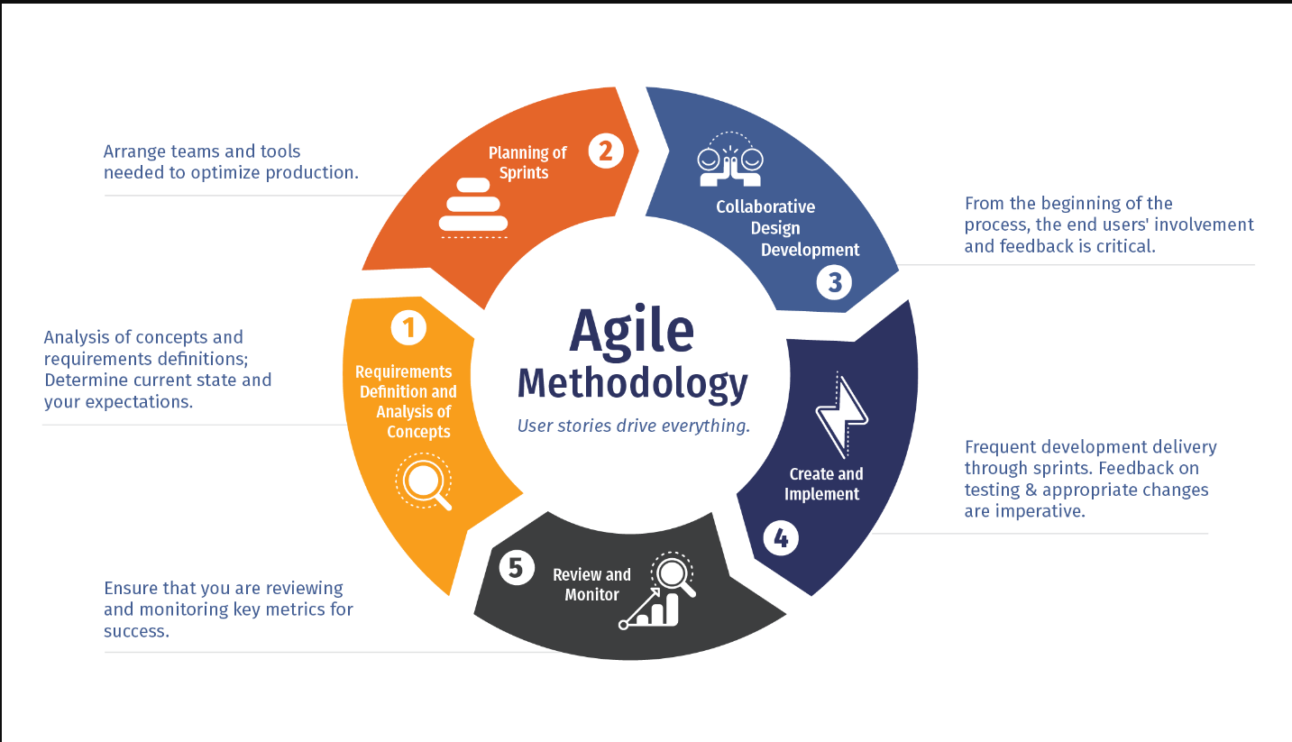

**Figure 1 Agile Methodology**

The choice of using Agile methodology for developing Ebhumi is driven by several key advantages that align with the dynamic and collaborative nature of the real estate industry. Here are some reasons why agile is a suitable approach for the development of Ebhumi:

1. **Adaptability to changing requirements:**

Real estate market demands are subject to change due to factors such as market trends, regulatory updates, or user feedback. Agile allows for flexibility, making it easier to adapt to changing requirements throughout the development process.

1. **Iterative development:**

Agile development promotes an iterative approach, where the project is divided into small, manageable increments called iterations. This allows for continuous feedback and improvements, ensuring that features are refined and meet user expectations.

1. **Rapid time to market:**

The real estate industry is competitive, and getting a product to market quickly is crucial. Agile method approach allows for the delivery of functional features in shorter development cycles, enabling a faster time to market for **E-Bhumi** .

1. **Customer centric approach:**

The real estate market is customer centric, and Agile places a strong emphasis on delivering value to end users. By involving customers throughout the development process, EBHUMI can be tailored to meet their needs and preferences more effectively.

## **1.6. Report Organization**

The required content for the project is structured into six main chapters. Chapter 1 is introductory part which explains about the overview of the system. Chapter 2, the Literature review part covers the background study, fundamental theories and the review of the relevant research presented by other researchers. The Chapter 3, System Analysis provides the outline, requirements along with the feasibility of the project. In Chapter 4 System is designed based on the overall model building with the appropriate algorithms. Here, system is designed following structured approach. Chapter 5 called Implementation and testing covers tools and technology used to build a system. It also deals with the testing and result analysis. In the end, Chapter 6 is Conclusion in which we summarized the overall outputs along with the appropriate recommendation for the betterment in future.

# **Chapter 2: Background Study And Literature Review**

## **2.1. Background Study**

The real estate industry, a cornerstone of global economies, has traditionally been characterized by complex and time-consuming processes, creating challenges for buyers, sellers, and real estate professionals. Recognizing the need for a transformative solution, the E-BHUMI project emerges against the backdrop of a rapidly evolving digital landscape. Traditional real estate transactions often suffer from information asymmetry, making it difficult for buyers to access comprehensive details about available properties. The usual way of doing things in real estate takes a long time and happens step by step, causing delays that makes both buyers and sellers annoyed. Using old fashioned paperwork and methods also puts important information at risk. People worry a lot about how safe and private their transactions are in traditional real estate practices.

In conclusion, the background study illuminates the context in which the E-BHUMI project is situated. By understanding the historical challenges of traditional real estate transactions, recognizing technological advancements, and identifying market trends, the project aims to address critical pain points and contribute to the ongoing evolution of the real estate industry.

## **2.2. Literature Review**

Digital transformation initiatives in the global real estate sector have gained significant traction, particularly in emerging economies such as Nepal, where sophisticated real estate software solutions have been successfully implemented. However, sustaining these software standards poses a considerable challenge, primarily due to the intricate nature of the system, the volatility of market dynamics, fluctuating prices, and the critical need for seamless market coordination. Notably, California, recognized as a highly developed region, grappled with a notable data glitch issue, leading to a year-long discrepancy in real estate data accuracy, exemplified by the San Diego house sales discrepancies in April and May.

The intricate relationship between housing costs, land demand, and the real estate market is underscored by critical factors, including the floor area ratio, price elasticity of land supply, and fee rates The comprehensive study on the Interaction between Land Market and Real Estate Market extensively examines this intricate interplay, conducting empirical tests to provide valuable insights and policy recommendations for effective real estate market regulations.

In their ground breaking study integrated the concept of home equity extraction (HEE) and mortgage securitization within the established Campbell and Mankiw (1989) model to thoroughly analyze the impact of housing wealth and mortgage liberalization. The study findings emphasize the profound influence of HEE on consumption patterns and the demonstrable effect of increased collateral emphasis by lenders, which facilitates greater equity withdrawal, thereby stimulating consumption.

The proposed real estate program aims to surpass its competitors, including well-known systems such as Gharghaderi, Gharjagganepal, Gharjaggabazar, and Gharjaggabuy, by incorporating innovative features such as an interactive chat interface. Additionally, the comprehensive coverage of the entire Nepal region, as opposed to selective areas, is expected to significantly contribute to the program's success. While various property buying and selling platforms like Nepal homes, Online Gharjagga, and ghar bazar have a presence, but it does not provide a smooth user interface and user experience.

# **Chapter 3: System Analysis**

## **3.1. System analysis**

### **3.1.1. Requirement analysis**

1. **Functional requirement**

* Search Property
* Property List
* Agent/ Admin/ User Management

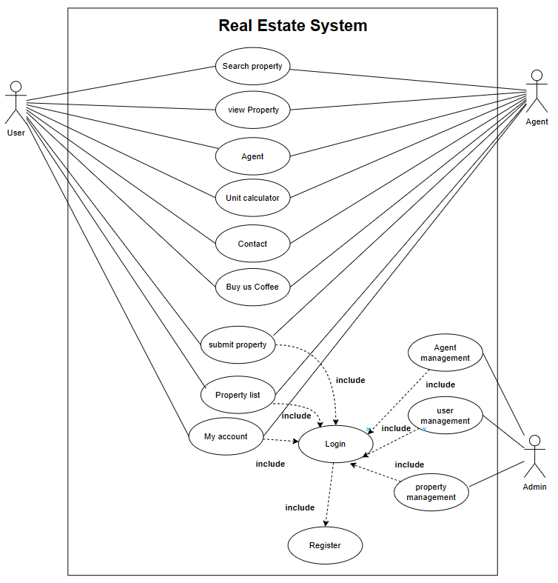

**Figure 2 Use Case Diagram**

The above use case entails that both users and agents are able to search for properties, view recently added properties, utilize a land unit calculator, make contact inquiries, and support the platform by buying us coffee. Upon logging in, users and agents gain additional functionalities such as submitting properties, managing their property listings (including updates and deletions), and accessing their account details. For the admin, post-login access enables management capabilities over users, properties, and agents, including the ability to add and delete entries as

1. **Non Functional requirements**

* security
* stability
* UX and UI
* Clean and aesthetic design

### **3.1.2. Feasibility analysis**

1. **Technical feasibility**

The technical feasibility of the E-BHUMI project is robust, leveraging well-established technologies to ensure a seamless and efficient development process.

* Utilizing HTML for structuring and CSS for styling, the front-end of E-BHUMI will offer an intuitive and visually appealing user interface. These technologies are widely supported, ensuring compatibility across various browsers and devices.
* PHP will serve as the back-end scripting language, providing dynamic functionality and server-side processing. Its versatility and compatibility with MySQL make it an ideal choice for handling user requests, data processing, and interaction with the database.
* VS Code, a lightweight yet powerful IDE, will be the development environment of choice. Its extensibility, support for various programming languages, and integration with Git facilitate collaborative and efficient coding practices.

The technical feasibility of E-BHUMI is well-founded, incorporating widely accepted technologies for both front-end and back-end development. The use of HTML, CSS, PHP, MySQL, and VS Code ensures a robust, scalable, and secure foundation for the development of a user-friendly and innovative real estate platform.

1. **Economic feasibility**

The E-BHUMI project demonstrates strong economic feasibility, driven by minimal hosting charges, development costs, and marketing expenses. Leveraging cost-effective technologies such as HTML, CSS, PHP, MySQL, and the use of Visual Studio Code for development ensures efficiency in resource utilization. With modern hosting solutions offering competitive rates, the ongoing operational expenses are kept low. Additionally, a streamlined marketing strategy focused on digital channels and organic growth will further contribute to cost-effectiveness. The project's economic viability is enhanced by its lean development approach, aligning technological choices with affordability, ultimately positioning E-BHUMI as a financially sustainable and resource-efficient real estate platform.

1. **Schedule feasibility**

We have estimated the time required for the completion of the project and diligently adhered to a fixed schedule, ensuring the project's timely completion. This proactive approach has proven instrumental in addressing potential constraints that the project might have encountered. By meticulously planning and executing according to the predetermined schedule, we have effectively managed resources, mitigated risks, and maintained a structured and efficient workflow throughout the development process.

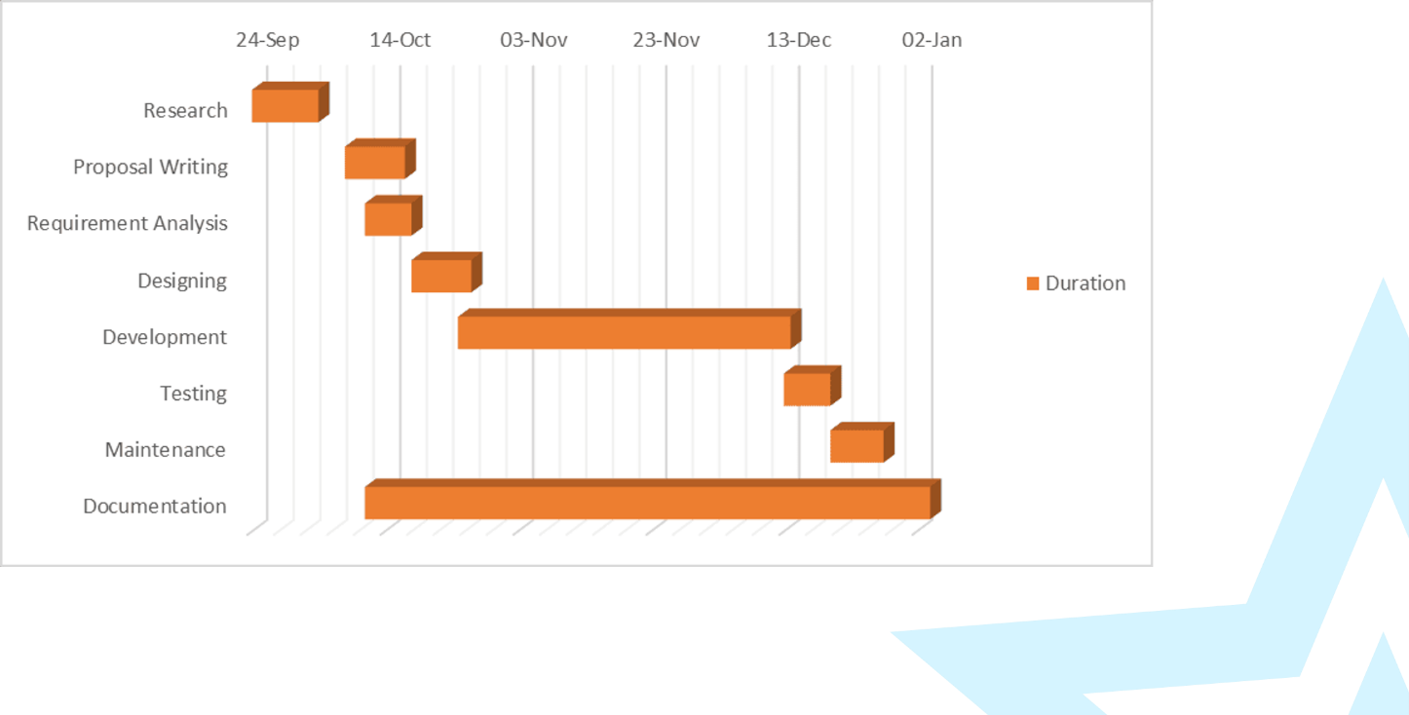

**Figure 3 Gantt chart**

# Chapter 4: System Design

## **4.1. Design**

### **4.1.1. Class diagram**

**Figure 4 Class Diagram chart**

### **4.1.2. ER Diagram**

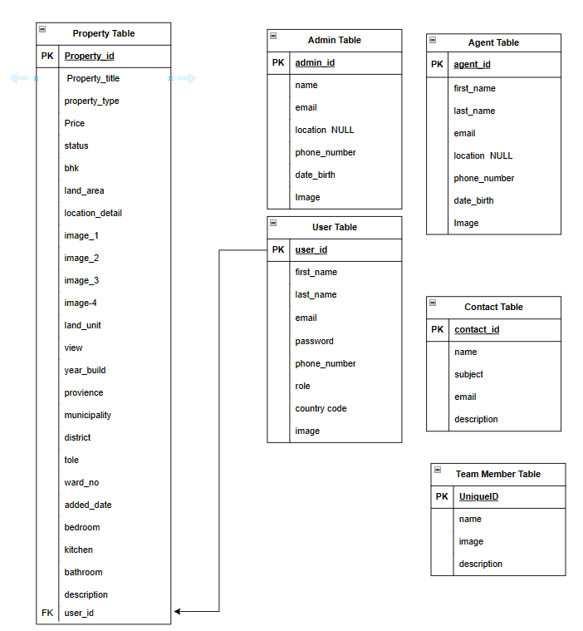The ER (Entity-Relationship) diagram for the E-BHUMI project incorporates key entities such as "Admin," "Subscription," and "User Activity," each playing a crucial role in the system. The "Admin" entity includes key attributes specific to administrative roles, ensuring effective management of the platform. The "Subscription" entity captures details related to user subscription plans, outlining key attributes associated with subscription management. The "User Activity" entity represents user interactions within the system, tracking essential attributes like login times, property views, and transaction history. Relationships between these entities are established, illustrating the connections between administrators, subscription plans, and user activities. This ER diagram provides a foundational structure for organizing and optimizing data pertaining to administrative functions, subscription management, and user engagement within the E-BHUMI platform.

**Figure 4 ER Diagram**

The diagram depicts tables for "property," "user," "contact," "team member," and "agent," with a relationship between the "property" table and the "user" table established via a foreign key.

## **4.2 Algorithm**

There are various algorithm or flows developed in order to implement various functions that are present in the “EBHUMI”. Some of the algorithms are given and described below.

### **4.2.1 flow for properties listing, update, and delete.**

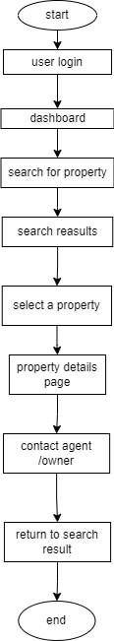

**Figure 5 properties view flowchart**

The above shown flowchart gives us idea about how various properties are viewed on the website. at the very first we perform the user login then we are sent to the dashboard from there we can search for the properties. after various properties are shown after the search operation is performed then we can select the properties that is fabourable according to our need then, after the selection of the certain property we can view the details of that property we can also contact the agent or the owner of the property.

### **4.2.2 flow for contacting the owner or agent.**

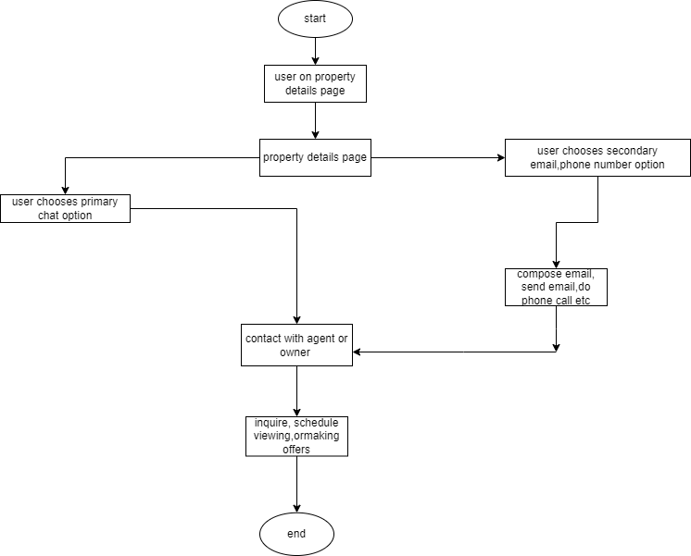

**Figure 6 contacting the agent or owner flow**

The above is the flow diagram or the algorithm that gives us the basic information about how a buyer can contact the agent or the owner of the property. Once we are on the details viewing page we basically have two options one is that the user can choose the primary chat option and another option is that user can choose secondary options like emails, phone numbers etc. from these options we can send emails, contact via phone numbers etc.

# Chapter 5: Implementation And Testing

## **5.1 Implementation**

### **5.1.1 Tool Used**

Implementation is the execution or practice of a plan, a method or any design, idea, model,

specification, standard or policy for doing something. As such, implementation is the action that

must follow any preliminary thinking for something to actually happen. Tools designed to support

specific business modeling techniques are often referred to as computer aided software engineering

(CASE) tools. A CASE tool is a product that helps to analyze, model and document business

processes. It is a tool or a toolset that supports the underlying principles and methods of analysis.

Programming Language is a high-level language used to write a computer program, which allows

programmers to write the source code in a natural fashion using logical words and symbols.

The major programming languages as well as the database tool we used to develop Examify are

given below.

* **HTML**

HTML, in full hypertext markup language, a formatting system for displaying material retrieved

over the Internet. Each retrieval unit is known as a Web page (from World Wide Web), and such

pages frequently contain hypertext links that allow related pages to be retrieved. HTML is the

markup language for encoding Web pages. HTML markup tags specify document elements such

as headings, paragraphs, and tables. They mark up a document for display by a computer program

known as a Web browser. The browser interprets the tags, displaying the headings, paragraphs,

and tables in a layout that is adapted to the screen size and fonts available to it.

* **CSS**

Cascading Style Sheets (CSS) is a style sheet language used for describing the presentation of a

document written in a markup language such as HTML or XML (including XML dialects such as

SVG, MathML or XHTML). CSS is a cornerstone technology of the World Wide Web, alongside

HTML and JavaScript. CSS is designed to enable the separation of content and presentation,

including layout, colors, and fonts. This separation can improve content accessibility; provide

more flexibility and control in the specification of presentation characteristics; enable multiple

web pages to share formatting by specifying the relevant CSS in a separate .css file, which reduces

complexity and repetition in the structural content; and enable the .css file to be cached to improve

the page load speed between the pages that share the file and its formatting.

* **JAVASCRIPT**

JavaScript is a programming language that is one of the core technologies of the World Wide Web,

alongside HTML and CSS. JavaScript is a high-level, often just-in-time compiled language that

conforms to the ECMAScript standard. It has dynamic typing, prototype-based object-orientation,

and first-class functions. It is multi-paradigm, supporting event-driven, functional, and imperative

programming styles. It has application programming interfaces (APIs) for working with text, dates,

regular expressions, standard data structures, and the Document Object Model (DOM).

* **XAMPP**

XAMPP, an acronym for "X (cross-platform), Apache, MySQL/MariaDB, PHP, and Perl," is a comprehensive web server solution stack offered by Apache Friends. Designed for various operating systems like Windows, Linux, and macOS, XAMPP simplifies the setup of a local web development environment. Its core components include the Apache HTTP Server for hosting websites, MySQL/MariaDB for managing relational databases, and PHP for server-side scripting. Additionally, it incorporates Perl and other tools essential for web development tasks. With its user-friendly installation process and bundled utilities like phpMyAdmin for database management, XAMPP streamlines the creation and testing of web applications offline before deployment to live servers. As a favored choice among developers, XAMPP empowers efficient coding and debugging by providing a hassle-free platform to replicate real-world hosting environments locally.

* **PHP**

PHP is a web development language written by and for developers. It is a programming

language that allows wed developers to create interactive and dynamic web pages. The first

version was originally created by Rasmus Lerdorf in 1994. PHP stands for “Hypertext

Processor” is a server-side scripting language, and is very similar to Java, Perl and C++. The

PHP has in recent time emerged as the most well-known general purpose scripting language

that is best suited for web development and web designing. As PHP is an open-source

language, it helps web designers and developers in building active web pages and providing

them an easier way to accomplish web related programming tasks. PHP as an application is

also very fast and secure with large usability features making it as a language more popular

among website designers and developers. The PHP can be run on almost all operating systems

such as windows XP, Linux etc. Thereby making more accessible to windows. The PHP is

integrated with a number of popular databases, including MYSQL and Oracle which provides

high security constraints and it is relatively cheap. Through PHP, web developers are more in

a position to make fast, secure and dynamic web portals with premium and well match

features. The PHP allows the programmer to dynamically generate content, instead of

statically like regular HTML.

* **Microsoft word Office**

Microsoft Words is Microsoft’s word processing software that I chose to document all the

documentation part. With Microsoft Word 2016, I found out that there are many benefits of

using it e.g., Live Preview which enables us to view the document without making any

permanent changes, Mini Toolbar, Super-tooltips, Quick Access toolbar, SmartArt, and many

more.

* **Microsoft PowerPoint**

This application is used for the documentation and presentation of the project. Microsoft

PowerPoint, usually just called PowerPoint, is a commercial presentation program developed

by Microsoft. It is part of the Microsoft Office suite, and runs on Microsoft Windows and

Apple's Mac OS X operating system.

* **Draw.io**

Draw.io is a versatile and intuitive online diagramming tool that empowers users to create a wide range of diagrams, flowcharts, mind maps, and more. With its user-friendly interface and extensive library of shapes and templates, Draw.io simplifies the process of visualizing ideas, processes, and data structures. We used this tool for Drawing Use Case, ER Diagram, Class Diagram, Flowchart.

* **Figma**

### **5.1.2 Implementation detail of Modules**

* **User/Agent Module**

One of the central features of our real estate platform is its property management modules, offering a comprehensive set of tools designed to empower users in handling property listings efficiently. Upon accessing the platform, users are greeted with a user-friendly dashboard displaying their submitted properties and associated details. From this hub, users can seamlessly submit new property listings, review their existing submissions, update property information, and remove listings as needed.

* **Admin Module**

Within our real estate platform “E-Bhumi”, administrators wield powerful tools to oversee user and property management, ensuring smooth operations and optimal user experiences. Administrators have the capability to access and review comprehensive profiles of all users and agents registered on the platform. From these profiles, they can update relevant details as necessary and remove accounts when required, maintaining data accuracy and platform integrity.

In addition to managing user profiles, administrators have the authority to modify and delete property listings. This includes updating property details to reflect changes accurately and removing listings that no longer meet platform standards or user requirements.

By empowering administrators with these capabilities, our real estate platform fosters efficient administration and facilitates seamless property management, ultimately enhancing the overall user experience and driving success in the real estate market.

* **Super Admin Module**

In our real estate platform, the Super Admin holds the highest level of authority, encompassing all functionalities available to regular administrators while also wielding exclusive control over administrative user profiles. While administrators can manage user and agent profiles, they do not possess the capability to modify or delete other administrator accounts. Instead, these privileges are reserved solely for the Super Admin.

Similar to administrators, the Super Admin can view all user and agent profiles, update their details, and delete them when necessary. Furthermore, the Super Admin retains the authority to update and delete property listings, ensuring platform integrity and data accuracy across all levels of administration.

By delineating these distinct roles and responsibilities, our real estate platform promotes efficient governance and safeguards sensitive administrative functionalities, bolstering security and maintaining operational efficiency at all times.

## **5.2 Testing**

Software testing is a method to check whether the actual software product matches expected requirements and to ensure that software product is Defect free. In short, software testing means verification of AUT. Out of the various testing strategies the following table summarizes the unit testing and system testing of the proposed system.

**Table 1: Test case for User’s Register Page**

|  |  |  |  |  |  |
| --- | --- | --- | --- | --- | --- |
| Test  ID | Test  Description | Input Test Data | Expected  Result | Actual  Result | Status |
| 1 | Enter valid  Details | First Name, Last Name, Phone Number, Email, Password , Image, Location, role | Redirect User to Login page | Redirect Sucessfull | pass |
| 2 | Enter Incomplete  Details | First Name, Last Name, Phone Number, Email, Password , Image, Location, role | Shows Error message | Show Error Success full | pass |

**Table 2: Test case for Super Admin’s Register Page**

|  |  |  |  |  |  |
| --- | --- | --- | --- | --- | --- |
| Test  ID | Test  Description | Input Test Data | Expected  Result | Actual  Result | Status |
| 1 | Enter valid  Details | First Name, Last Name, Phone Number, Email, Password , Image, Location, role | Redirect User to Login page | Redirect Sucessfull | pass |
| 2 | Enter Incomplete  Details | First Name, Last Name, Phone Number, Email, Password , Image, Location, role | Shows Error message Redirect  To Register Page | Show Error Success full | pass |

**Table 3: Test case for User’s/Agent’s Login Page**

|  |  |  |  |  |  |
| --- | --- | --- | --- | --- | --- |
| Test  ID | Test  Description | Input Test Data | Expected  Result | Actual  Result | Status |
| 1 | Enter valid  Details | Email, Password | Redirect User to Home page | Redirect Sucessfull | pass |
| 2 | Enter Incomplete  Details | Email, Password | Shows Error message redirect  to Login page | Show Error Success full | pass |

**Table 4: Test case for Admin’s Login Page**

|  |  |  |  |  |  |
| --- | --- | --- | --- | --- | --- |
| Test  ID | Test  Description | Input Test Data | Expected  Result | Actual  Result | Status |
| 1 | Enter valid  Details | Email, Password | Redirect User to Home page | Redirect Successfull | pass |
| 2 | Enter Incomplete  Details | Email, Password | Shows Error message redirect to Login page | Show Error Success full | pass |

**Table 5: Test case for Super Admin’s Login Page**

|  |  |  |  |  |  |
| --- | --- | --- | --- | --- | --- |
| Test  ID | Test  Description | Input Test Data | Expected  Result | Actual  Result | Status |
| 1 | Enter valid  Details | Email, Password | Redirect User to Home page | Redirect Successfull | pass |
| 2 | Enter Incomplete  Details | Email, Password | Shows Error message redirect to Login page | Show Error Success full | pass |

**Table 6: Test case for User’s/Agent’s Submit page**

|  |  |  |  |  |  |
| --- | --- | --- | --- | --- | --- |
| Test  ID | Test  Description | Input Test Data | Expected  Result | Actual  Result | Status |
| 1 | When the user click on submit | Tile, property type , BHK, bedroom, kitchen, bathroom, Status, land area , unit , year build, price, Provience, municipality, tole, ward no, image, image 1, image 2 , image 3 , description | Property Added  Successfully and  redirect to submit page | Property Added  successful and redirect to submit page | pass |
| 2 | When the user click on to submit  incomplete detail | Tile, property type , BHK, bedroom, kitchen, bathroom, Status, land area , unit , year build, price, Provience, municipality, tole, ward no, image, image 1, image 2 , image 3 , description | Shows Error message redirect to Submit page | Shows Error message redirect to Submit page | pass |

**Table 7: Test case for User’s/Agent’s Property List page**

|  |  |  |  |  |  |
| --- | --- | --- | --- | --- | --- |
| Test  ID | Test  Description | Input Test Data | Expected  Result | Actual  Result | Status |
| 1 | When the user clicks on Update button | Null | Redirects to Update Property Page | Redirects to Update Property Page | pass |
| 2 | When the user clicks on Delete | Null | Property Deleted successfully | Property Deleted successfully | pass |

**Table 8: Test case for User’s/Agent’s Property Update page**

|  |  |  |  |  |  |
| --- | --- | --- | --- | --- | --- |
| Test  ID | Test  Description | Input Test Data | Expected  Result | Actual  Result | Status |
| 1 | When the user clicks on submit | Tile, property type , BHK, bedroom, kitchen, bathroom, Status, land area , unit , year build, price, Provience, municipality, tole, ward no, image, image 1, image 2 , image 3 , description | Property is Sucessfully Updated and  Redirects to Update Property Page | Property is Sucessfully Updated and  Redirects to Update Property Page | pass |
| 2 | When the user clicks on submit with incomplete detail | Tile, property type , BHK, bedroom, kitchen, bathroom, Status, land area , unit , year build, price, Provience, municipality, tole, ward no, image, image 1, image 2 , image 3 , description | Shows Error message redirect to Submit page | Shows Error message redirect to Submit page | pass |

**Table 9: Test case for User’s/Agent’s Contact Page**

|  |  |  |  |  |  |
| --- | --- | --- | --- | --- | --- |
| Test  ID | Test  Description | Input Test Data | Expected  Result | Actual  Result | Status |
| 1 | When the user clicks on Send Message button | Name , Email address, Subject, Description | Send message Successful Redirect to Contact page | Send message Successful Redirect to Contact page | pass |
| 2 | When the user clicks on Send Message button incomplete details | Name , Email address, Subject, Description | Shows Error message redirect to Contact page | Shows Error message redirect to Contact page | pass |

**Table 10: Test case for Admin’s User’s/Agent’s Page**

|  |  |  |  |  |  |
| --- | --- | --- | --- | --- | --- |
| Test  ID | Test  Description | Input Test Data | Expected  Result | Actual  Result | Status |
| 1 | When admin click on update | First Name, Last Name, Phone Number, Email, Password , Image, Location, role | Redirect User to Home page | Redirect Sucessfull | pass |
| 2 | When admin on any role click on Delete | Null | The User/Agent Sucessfully  deleted | The user Sucessfully deleted | pass |

# **Chapter 6: Conclusion and Future Recommendation**

## **6.1 Conclusion**

In conclusion, our real estate development project represents a harmonious fusion of innovation, functionality, and sustainability in the ever evolving landscape of the property market. Our real estate website emerges as a ground breaking platform set to revolutionize the way properties are bought and sold. By leveraging cutting edge technology and user centric designs, we strive to create seamless and empowering experience for both buyers and sellers. Our commitment to transparency, accessibility, and efficiency sets us apart in the competitive real estate market.

As we pave the way for a new era in property transactions, our website aims to simplify the process, offering intuitive tools and features that enhance the user journey. From comprehensive property listings and advanced search functionalities to secure transaction processes, we prioritize the users

Needs at every step.

With a vision to foster a thriving online community of real estate enthusiasts, our platform is not just about transactions its about building connections and facilitating informed decisions. As we move forward, we are excited about the positive impact our website will have on the real estate industry, bringing together buyers and sellers in a digital space that prioritizes efficiency, trust, and a seamless users experience, join us in redefining the future of real estate transactions where convenience meets innovation.

## **6.2 Future Recommendation**

# **Reference**

* What is agile methodology? benefits of using agile (no date a) nvisia. Available at: https://www.nvisia.com/insights/agile-methodology (Accessed: 21 March 2024).
* (No date) Find best real estate properties in nepal gharghaderi.com. Available at: https://www.gharghaderi.com/ (Accessed: 21 March 2024).
* (No date) Find best real estate properties in nepal gharghaderi.com. Available at: https://www.gharghaderi.com/ (Accessed: 21 March 2024).
* Land For Sale (no date a) Ghar Jagga Nepal. Available at: https://gharjagganepal.com/ (Accessed: 21 March 2024).
* Ghar Jagga Buy (2023) The best real estate solution in Nepal. Available at: https://gharjaggabuy.com/ (Accessed: 21 March 2024).

**Meeting Report**

|  |  |  |  |
| --- | --- | --- | --- |
| MEETING REPORT 1ST | | | |
| Project Name: | “E-Bhumi”- A Real Estate System | | |
| Date of Meeting: |  | Time: | 7:00 am – 9:00 am |
| Supervisor: | Pratik Gautam | Location: | Godawari College |
| 1. What we did this weeks: | | | |
| * Project Topic Discuss | | | |
| 1. Attendees: | | | |
| Name: | | Email | |
| Bikesh kc | | bikeshkc321@gmail.com | |
| Suman Dhungana | | sumandhungana85@gmail.com | |
| Aayush Luitel | | aayushluitel797@gmail.com | |
| 1. What we will do next weeks: | | | |
| * Introduction * Problem Statement * Objective | | | |
| 1. Assigned Work To: | | | |
| Task Description: | | Prepared By: | |
| Introduction, | | Suman Dhungana , bikesh k.c. , aayush Luitel | |
| Problem | | Suman Dhungana , bikesh k.c. , aayush Luitel | |
| Statement | | Suman Dhungana , bikesh k.c. , aayush Luitel | |

**Meeting Report**

|  |  |  |  |
| --- | --- | --- | --- |
| MEETING REPORT 2ND | | | |
| Project Name: | “E-Bhumi”- A Real Estate System | | |
| Date of Meeting: |  | Time: | 7:00 am – 9:00 am |
| Supervisor: | Pratik Gautam | Location: | Godawari College |
| 1. What we did this weeks: | | | |
| * Introduction * Problem Statement * Objective | | | |
| 1. Attendees: | | | |
| Name: | | Email | |
| Bikesh kc | | bikeshkc321@gmail.com | |
| Suman Dhungana | | sumandhungana85@gmail.com | |
| Aayush Luitel | | aayushluitel797@gmail.com | |
| 1. What we will do next weeks: | | | |
| * System Analysis * Initial Flow Chart * Initial Use Case | | | |
| 1. Assigned Work To: | | | |
| Task Description: | | Prepared By: | |
| System Analysis | | Suman Dhungana , Aayush Luitel | |
| Flow Chart | | Suman Dhungana , Bikesh k.c. | |
| Use Case | | Bikesh k.c. | |

**Meeting Report**

|  |  |  |  |
| --- | --- | --- | --- |
| MEETING REPORT 3RD | | | |
| Project Name: | “E-Bhumi”- A Real Estate System | | |
| Date of Meeting: |  | Time: | 7:00 am – 9:00 am |
| Supervisor: | Pratik Gautam | Location: | Godawari College |
| 1. What we did this weeks: | | | |
| * System Analysis * Initial Flow Chart * Initial Use Case | | | |
| 1. Attendees: | | | |
| Name: | | Email | |
| Bikesh kc | | bikeshkc321@gmail.com | |
| Suman Dhungana | | sumandhungana85@gmail.com | |
| Aayush Luitel | | aayushluitel797@gmail.com | |
| 1. What we will do next weeks: | | | |
| * Literature review * Background Study * DataBase Schema Design * Initial proposal Defence | | | |
| 1. Assigned Work To: | | | |
| Task Description: | | Prepared By: | |
| Literature review | | Aayush Luitel | |
| Background | | Aayush Luitel | |
| Database Schema Design | | Suman Dhungana | |
| Initial Proposal Defence | | Suman Dhungana , Aayush Luitel , Bikesh K.c. | |

**Meeting Report**

|  |  |  |  |
| --- | --- | --- | --- |
| MEETING REPORT 4TH | | | |
| Project Name: | “E-Bhumi”- A Real Estate System | | |
| Date of Meeting: |  | Time: | 7:00 am – 9:00 am |
| Supervisor: | Pratik Gautam | Location: | Godawari College |
| 1. What we did this weeks: | | | |
| * Literature review * Background Study * DataBase Schema Design * Initial proposal Defence | | | |
| 1. Attendees: | | | |
| Name: | | Email | |
| Bikesh kc | | bikeshkc321@gmail.com | |
| Suman Dhungana | | sumandhungana85@gmail.com | |
| Aayush Luitel | | aayushluitel797@gmail.com | |
| 1. What we will do next weeks: | | | |
| * Figma design * Home Page coding * Sell/Buy Page Coding | | | |
| 1. Assigned Work To: | | | |
| Task Description: | | Prepared By: | |
| Figma Design | | Bikesh k.c. , Suman Dhungana , Aayush Luitel | |
| Home Page Coding | | Bikesh K.c. | |
| Sell/Buy page Coding | | Bikesh k.c. | |

**Meeting Report**

|  |  |  |  |
| --- | --- | --- | --- |
| MEETING REPORT 5TH | | | |
| Project Name: | “E-Bhumi”- A Real Estate System | | |
| Date of Meeting: |  | Time: | 7:00 am – 9:00 am |
| Supervisor: | Pratik Gautam | Location: | Godawari College |
| 1. What we did this weeks: | | | |
| * Figma design * Home Page coding * Sell / Buy Page coding | | | |
| 1. Attendees: | | | |
| Name: | | Email | |
| Bikesh kc | | bikeshkc321@gmail.com | |
| Suman Dhungana | | sumandhungana85@gmail.com | |
| Aayush Luitel | | aayushluitel797@gmail.com | |
| 1. What we will do next weeks: | | | |
| * Redesign Home page * Recent Property Section of home Page Coding * Footer redesign | | | |
| 1. Assigned Work To: | | | |
| Task Description: | | Prepared By: | |
| Redesign Home Page | | Bikesh k.c. | |
| Recent Property Section of home page Coding | | Bikesh K.c. | |
| Footer redesign | | Bikesh K.c. | |

**Meeting Report**

|  |  |  |  |
| --- | --- | --- | --- |
| MEETING REPORT 6TH | | | |
| Project Name: | “E-Bhumi”- A Real Estate System | | |
| Date of Meeting: |  | Time: | 7:00 am – 9:00 am |
| Supervisor: | Pratik Gautam | Location: | Godawari College |
| 1. What we did this weeks: | | | |
| * Redesign Home page * Recent Property Section of home Page Coding * Footer redesign | | | |
| 1. Attendees: | | | |
| Name: | | Email | |
| Bikesh kc | | bikeshkc321@gmail.com | |
| Suman Dhungana | | sumandhungana85@gmail.com | |
| Aayush Luitel | | aayushluitel797@gmail.com | |
| 1. What we will do next weeks: | | | |
| * Complete Front End * Login and Register | | | |
| 1. Assigned Work To: | | | |
| Task Description: | | Prepared By: | |
| Complete Front end | | Bikesh k.c. | |
| Login and Register | | Suman Dhungana | |
| - | | - | |

**Meeting Report**

|  |  |  |  |
| --- | --- | --- | --- |
| MEETING REPORT 7TH | | | |
| Project Name: | “E-Bhumi”- A Real Estate System | | |
| Date of Meeting: |  | Time: | 7:00 am – 9:00 am |
| Supervisor: | Pratik Gautam | Location: | Godawari College |
| 1. What we did this weeks: | | | |
| * Complete Front End * Login and Register | | | |
| 1. Attendees: | | | |
| Name: | | Email | |
| Bikesh kc | | bikeshkc321@gmail.com | |
| Suman Dhungana | | sumandhungana85@gmail.com | |
| Aayush Luitel | | aayushluitel797@gmail.com | |
| 1. What we will do next weeks: | | | |
| * Submit property * Meet Our Team Dynamic * Admin FrontEnd login/register | | | |
| 1. Assigned Work To: | | | |
| Task Description: | | Prepared By: | |
| Submit property | | Suman Dhungana | |
| Meet Our Team Dynamic | | Suman Dhungana | |
| Admin FrontEnd login/ register | | Bikesh K.c. | |

**Meeting Report**

|  |  |  |  |
| --- | --- | --- | --- |
| MEETING REPORT 8TH | | | |
| Project Name: | “E-Bhumi”- A Real Estate System | | |
| Date of Meeting: |  | Time: | 7:00 am – 9:00 am |
| Supervisor: | Pratik Gautam | Location: | Godawari College |
| 1. What we did this weeks: | | | |
| * Submit Property * Meet Our Team Dynamic * Admin FrontEnd login/ register | | | |
| 1. Attendees: | | | |
| Name: | | Email | |
| Bikesh kc | | bikeshkc321@gmail.com | |
| Suman Dhungana | | sumandhungana85@gmail.com | |
| Aayush Luitel | | aayushluitel797@gmail.com | |
| 1. What we will do next weeks: | | | |
| * Propertydetail Dynamic * My account Dynamic * Index Recent property Dynamic | | | |
| 1. Assigned Work To: | | | |
| Task Description: | | Prepared By: | |
| Propertydetail Dynamic | | Suman Dhungana | |
| My account Dynamic | | Suman Dhungana | |
| Index Recent Property Dynamic | | Suman Dhungana | |

**Meeting Report**

|  |  |  |  |
| --- | --- | --- | --- |
| MEETING REPORT 9TH | | | |
| Project Name: | “E-Bhumi”- A Real Estate System | | |
| Date of Meeting: |  | Time: | 7:00 am – 9:00 am |
| Supervisor: | Pratik Gautam | Location: | Godawari College |
| 1. What we did this weeks: | | | |
| * Propertydetail Dynamic * My account Dynamic * Index Recent property Dynamic | | | |
| 1. Attendees: | | | |
| Name: | | Email | |
| Bikesh kc | | bikeshkc321@gmail.com | |
| Suman Dhungana | | sumandhungana85@gmail.com | |
| Aayush Luitel | | aayushluitel797@gmail.com | |
| 1. What we will do next weeks: | | | |
| * PropertyList Dynamic * View all Properties Dynamic * Submit property using ajax for update and delete of the property * Admin dashboard/User list frontend | | | |
| 1. Assigned Work To: | | | |
| Task Description: | | Prepared By: | |
| PropertyList Dynamic | | Suman Dhungana | |
| View all properties Dynamic | | Suman Dhungana | |
| Submit Property using ajax for update and delete of property | | Suman Dhungana | |
| Admin dashboard/User List fontend | | Bikesh K.c | |

**Meeting Report**

|  |  |  |  |
| --- | --- | --- | --- |
| MEETING REPORT 9TH | | | |
| Project Name: | “E-Bhumi”- A Real Estate System | | |
| Date of Meeting: |  | Time: | 7:00 am – 9:00 am |
| Supervisor: | Pratik Gautam | Location: | Godawari College |
| 1. What we did this weeks: | | | |
| * PropertyList Dynamic * View all Properties Dynamic * Submit property using ajax for update and delete of the property * Admin dashboard/User list frontend | | | |
| 1. Attendees: | | | |
| Name: | | Email | |
| Bikesh kc | | bikeshkc321@gmail.com | |
| Suman Dhungana | | sumandhungana85@gmail.com | |
| Aayush Luitel | | aayushluitel797@gmail.com | |
| 1. What we will do next weeks: | | | |
| * Bug fix Submit property using ajax * Super admin and Admin Differentiate & login/register * Dashboard card Dynamic * Admin Property view | | | |
| 1. Assigned Work To: | | | |
| Task Description: | | Prepared By: | |
| Bug Fix Submit Property using ajax | | Suman Dhungana | |
| Super Admin and Admin Differentiate & login/register | | Suman Dhungana | |
| Dashboard card Dynamic | | Suman Dhungana | |
| Admin paoperty view | | Bikesh K.c , Suman Dhungana | |

**Meeting Report**

|  |  |  |  |
| --- | --- | --- | --- |
| MEETING REPORT 10TH | | | |
| Project Name: | “E-Bhumi”- A Real Estate System | | |
| Date of Meeting: |  | Time: | 7:00 am – 9:00 am |
| Supervisor: | Pratik Gautam | Location: | Godawari College |
| 1. What we did this weeks: | | | |
| * Bug fix Submit property using ajax * Super admin and Admin Differentiate & login/register * Dashboard card Dynamic * Admin Property view | | | |
| 1. Attendees: | | | |
| Name: | | Email | |
| Bikesh kc | | bikeshkc321@gmail.com | |
| Suman Dhungana | | sumandhungana85@gmail.com | |
| Aayush Luitel | | aayushluitel797@gmail.com | |
| 1. What we will do next weeks: | | | |
| * Admin property view Dynamic * By us coffee Esewa Static QR code Integrate * Some bug fix in admin and main page * Unit Testing | | | |
| 1. Assigned Work To: | | | |
| Task Description: | | Prepared By: | |
| Admin property view Dynamic | | Suman Dhungana | |
| By us coffee Esewa Static QR code integrate | | Suman Dhungana | |
| Some bug fix in admin mian page | | Suman Dhungana | |
| Unit Testing | | Bikesh K.c , Suman Dhungana | |

**Meeting Report**

|  |  |  |  |
| --- | --- | --- | --- |
| MEETING REPORT 10TH | | | |
| Project Name: | “E-Bhumi”- A Real Estate System | | |
| Date of Meeting: |  | Time: | 7:00 am – 9:00 am |
| Supervisor: | Pratik Gautam | Location: | Godawari College |
| 1. What we did this weeks: | | | |
| * Admin property view Dynamic * By us coffee Esewa Static QR code Integrate * Some bug fix in admin and main page * Unit Testing | | | |
| 1. Attendees: | | | |
| Name: | | Email | |
| Bikesh kc | | bikeshkc321@gmail.com | |
| Suman Dhungana | | sumandhungana85@gmail.com | |
| Aayush Luitel | | aayushluitel797@gmail.com | |
| 1. What we will do next weeks: | | | |
| * Testing all the Input field functions and button * Maintenance * Documentation | | | |
| 1. Assigned Work To: | | | |
| Task Description: | | Prepared By: | |
| Testing all the Input field functions and buttons | | Suman Dhungana , Bikesh k.c, Aayush Luitel | |
| Maintenance | | Suman Dhungana,bikeshk k.c, Aayush Luitel | |
| Documentation | | Suman Dhungana, Bikesh K.c, Aayysh Luitel | |
| - | | - | |